Kurt Cobain: the journals
Early 1991: 'I cried to "Seasons of the Sun"'
Nirvana, hitherto a cult 'alternative' band, sign with Geffen Records, securing a handsome advance; the recording sessions for the album Nevermind are under way and within months, post-'Smells Like Teen Spirit', Cobain will become the biggest rock star in the world. He pens a brief autobiography in his notebook.
Next page: Bingeing on fame, autumn 1991 to spring 1992
Kurt Cobain's journals: Observer special
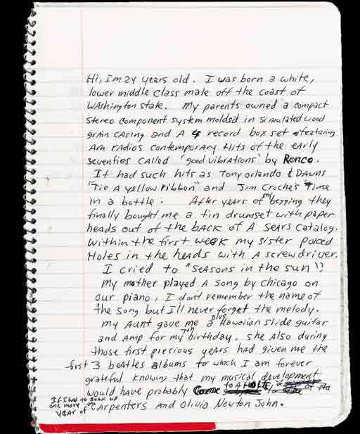

Kurt Cobain: the journals
Autumn 1991 to spring 1992: 'I got a little habit...'
Loser no more. Huge fame hits, as only overnight rock fame can: the massively successful album (Nevermind ousts Michael Jackson's Dangerous as Billboard's number one); the high-profile girlfriend (he marries Courtney Love on February 24 1992) and a developing drug habit with what he likes to call 'heroine'. He's also taken a dislike to the British press.
Next page: 'Smells like thirtysomething...', spring 1992
Kurt Cobain's journals: Observer special
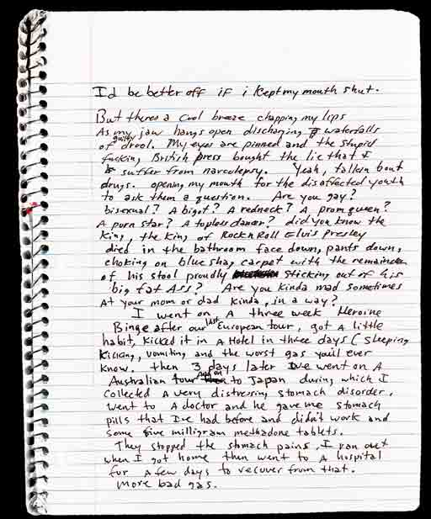

Kurt Cobain: the journals
Spring 1992: 'Smells like thirtysomething...'
One favourite Cobain strategy for dealing with fame is to adopt punk rock attitudes, play the rebel. He writes to Rolling Stone explaining why he won't do an interview, an unmailed letter. (He agrees to do the interview a few months later)
Next page: Fatherhood and survival, summer 1992
Kurt Cobain's journals: Observer special
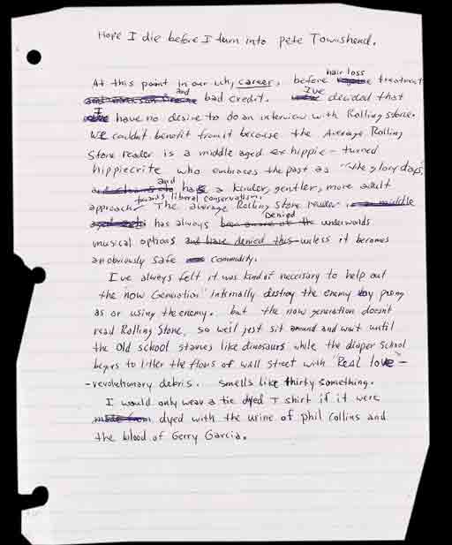

Kurt Cobain: the journals
Summer 1992: 'We will survive...'
Frances Bean Cobain is born on August 18. But while Love gives birth, Cobain is in the chemical dependency wing of the same hospital, Cedars-Sinai in Los Angeles. Vanity Fair publishes an article by Lynn Hirschberg alleging that Love had a habit during pregnancy; a story picked up by MTV. Cobain blasts his media tormentors. (Kurt Loder is also a journalist)
Next page: Kurdt's many moods, late 1992
Kurt Cobain's journals: Observer special
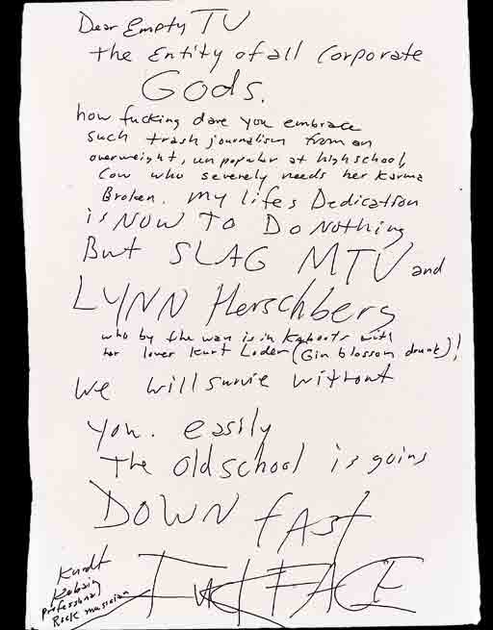

Kurt Cobain: the journals
Late 1992: 'Maybe I could squeeze my friends in'
Cobain takes to calling himself or, more specifically his rock persona, 'Kurdt' - with an added 'd'. The Many Moods gallery he creates from medical textbooks of deformed bodies.
Next page: Disappointing my father, spring 1993
Kurt Cobain's journals: Observer special
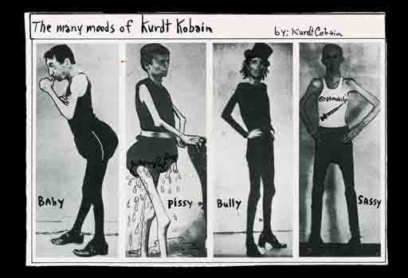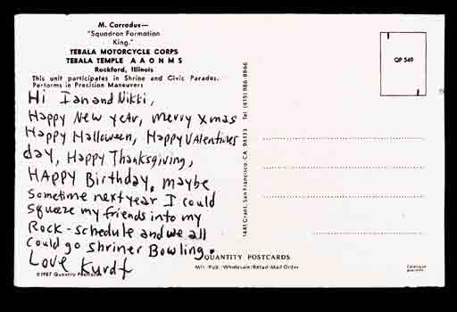

Kurt Cobain: the journals
Spring 1993: 'He's gonna be a football player...'
Or not. After the birth of Frances, Cobain starts to reflect on his relationship with his father Don, from whom he is estranged. In the spring of 93, he writes an unsent letter to Don describing his contempt for him. In this earlier cartoon, Cobain suggests that he had not met Don's macho expectations.
Next page: Love letter to Courtney, spring 1993
Kurt Cobain's journals: Observer special
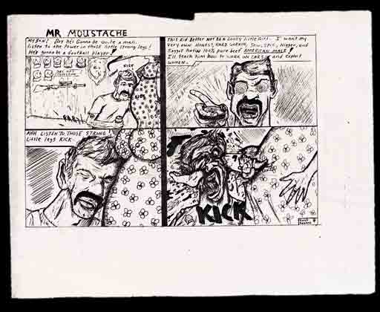

Kurt Cobain: the journals
Spring 1993: 'I parade you around proundly...'
In February, Cobain and Love celebrate their first anniversary; a tempestuous relationship which Cobain tries to make sense of in his sketch of a letter.
Next page: How drugs consume you, spring 1994
Kurt Cobain's journals: Observer special
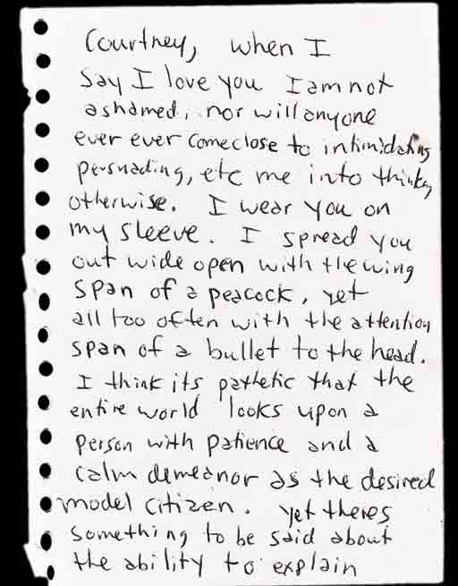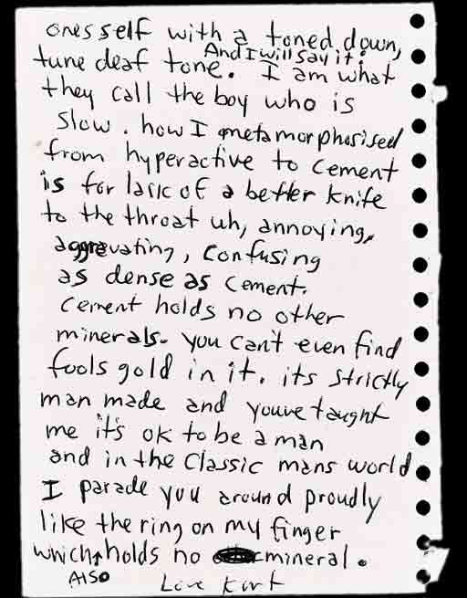

Kurt Cobain: the journals
Spring 1994: 'It can gradually consume you...'
Nirvana are a few days into their final European tour, when Cobain sits down in his Madrid hotel room to offer his most detailed account of the workings of his drug habit.
Spring 1994: 'I choose death'
Soon afterwards, Cobain was rushed to hospital in Rome with a distraught Courtney Love, having taken an overdose of Rohypnol, leaving behind a suicide note. 'Like Hamlet, I have to choose between life and death. I choose death.' He is in a coma for 20 hours but he survives. Weeks later, he tries again at home in Seattle. His dead body is found on 8 April.
Kurt Cobain's journals: Observer special
